**Yavuz Can Kocoglu**

**R11433416**

**Goksu Water Treatment Constructing and Contracting firm**

**Mechanical Engineering**

Introduction

When I decided to become an engineer, I didn’t know what I was getting myself into. However, I look at things differently now. I now realize, that the world is too dependent on us engineers. When I was taking math and engineering classes, I was wondering where I would use them. For that reason, I wanted to start it by doing an internship. I applied to the Goksu Water Treatment Constructing and Contracting firm.

The truth to be said, I know nothing about the company’s history. I don’t know when the company started, what jobs company did in the past. I applied to the company just to get experience of working. However, I gained a lot from this experience.

Description

The Goksu Water Treatment firm has few worksites around Turkey. Their original headquarters is located at Mersin (City of Turkey). They have 3 worksites around Turkey. The cities they were located were Kalkan, Antalya and Akhisar. They are small town like Lubbock actually. I never went to headquarter of the company. I only worked at the worksite at the Akhisar. My supervisor lives at the Izmir, which is my hometown. The distance from Izmir to the worksite at the Akhisar is one and half hours with a car.

My supervisor’s name is Gokay Avci. He is Environment Engineer/Project Manager of the company. At is the best translation for his position in the Company we could come up with. He would usually go to his office at Akhisar and finish most of his business from there. If he needed to be at other worksites or at the headquarters, he would drive there. He is the busiest people of the company. Every single project of the company has to pass through his inspection and must be approved by him.

The Goksu Water Treatment Company worksites are located in rural areas of the country because they clean the waters of the factories. Water treatment is a must for every factories. That is why factories, instead of having water treatment system for themselves, they come together and hire a water treatment company to do the job.

The truth to be said, the one that signs the contract with the water treatment company is government. The company only builds the water treatment plant and they make sure that the water treatment plant is functional. They build the water treatment plant and during that process, the officials from the government settles at the worksite. They inspect and report to the government if the company does its job properly. I do not know what else they do because we never talked with each other. They are rude people, they don’t even say hi to the interns or to the workers. The officials from the government settled when the Company is done with building the primary facilities. Once the secondary sections are built, the Company will leave everything to the government officials.

The water treatment facilities are built between four to five factories. They send their dirty water to the water treatment plant, so it cleans them and sends them back to the factories. The worksite at the Akhisar was surrounded by four factories. Olive factory, kağıt helva(some kind of wafer that sells in Turkey, I don’t think they are popular) factory, granite factory, and there was one more that I can’t remember. They would send dirty waters and sometimes their own products to the worksite.

Arrival

My flight to Turkey was on 15th July, when the Turkish coup d’état happened. Because of that my starting day for the internship was postponed to one week later. I was supposed to start on 18th July, but I started at 25th July. However, I still did the 20 days standard unpaid internship. Because of that, I was able to spend more time with my mom, and finish some of my personal businesses.

On 25th July, I and my supervisor met in front of his house and Electrical Engineer called Cemal Kaya picked us up with a black Toyota Camry 2007 provided by the company. We started moving at 7:30am and arrived at 9:00am. The first days were kind of uncomfortable for me because we have to go through a mountain road. It took me few days to get used to it. When we arrived at the worksite, I made acquainted with some people there. When we always arrive, we eat breakfast there and lunch at 12:00pm.

The worksite at Akhisar was actually almost complete. They almost built the water treatment plant. They only had to complete the secondary sections, make sure the water treatment plant is built and machines work properly and make the computer program for the MBR unit. Secondary sections and MBR will be explained properly at orientation. The first week wasn’t too much busy. Most of the people were on vacation. Because they recently finished the project at Antalya, so they wanted to take a break. There people who were at the company were Gokay Avci my supervisor, Cemal Kaya the Electrical engineer, Kadir Kusbeci the computer programmer and Murat one of the workers. These were excluding the charwomen and officials from the government.

Orientation

The first thing I was taught was safety rules. Then I was given orientation of the worksite by my supervisor personally. He took me to end of the orientation first, because Cemal Kaya and Murat were measuring the flow speed and taking samples from the water that is supposed to be cleaned. They weren’t exactly measuring the flow speed of the treated water. A new machine arrived from United States that measures the flow speed. They were using that last section to figure out the machine. The sample for to see if water was treated right. He also showed the small farm they built at the worksite. They produce melon, watermelon, chili, eggplant and tomato.

We didn’t stay there too much and we moved on with the orientation. While we were moving to the first section he told me about the factories around the worksite and what was the purpose of the water treatment plant here. I learned that they treat dirty water from the factories and send them back to those factories. He also told me that the government does the deal with the Goksu Water Treatment firm to build the plant.

Most of the sections are built like a small concrete buildings. They all have different duties. The water is treated with order, and it transfers to the sections from underground pipes. The water treatment has 2 parts, Macro and Micro. At macro, they clean the water from the big trashes and wastes, and at micro, they clean the microscopic wastes.

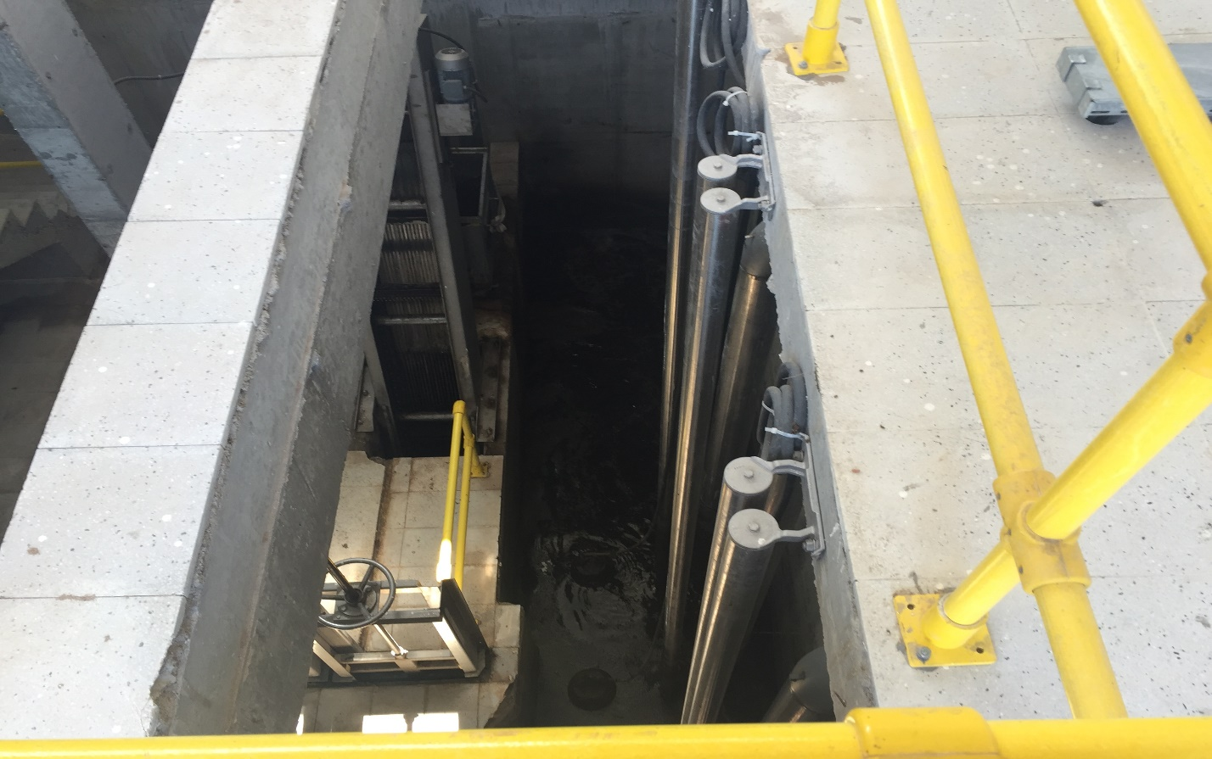

Picture 1

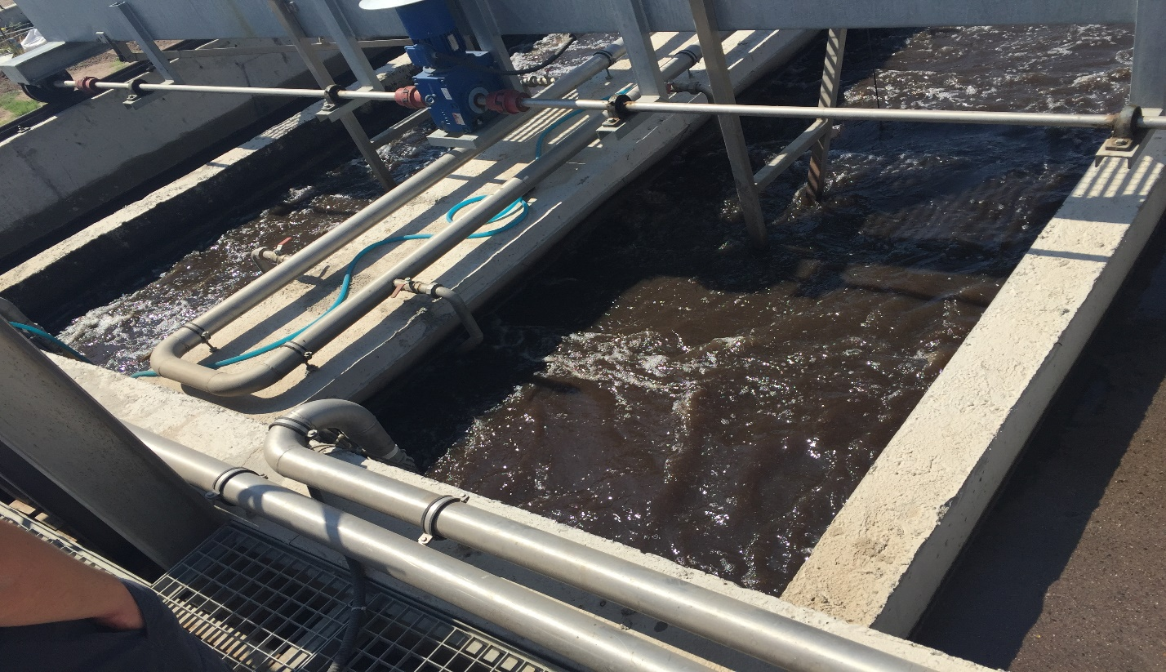Picture 2

“Picture 1” and “Picture 2” are part of the section 1. “Picture 1” is inside of the concrete building. It is actually goes 2 floor deep. I have been told, that building smells worst of all sections. Because the dirty water from the factories comes to there first. Luckily for me, they left the door open so, it didn’t smell. They clean the water there as much as possible, then they send it to the place at “Picture 2”, which is the roof of that concrete building. It is cleaned there as much as possible. There is a machine that can be used manually to clean the water. By pressing a button, the machine goes back and forth. The wastes are thrown to the trash can to be disposed.

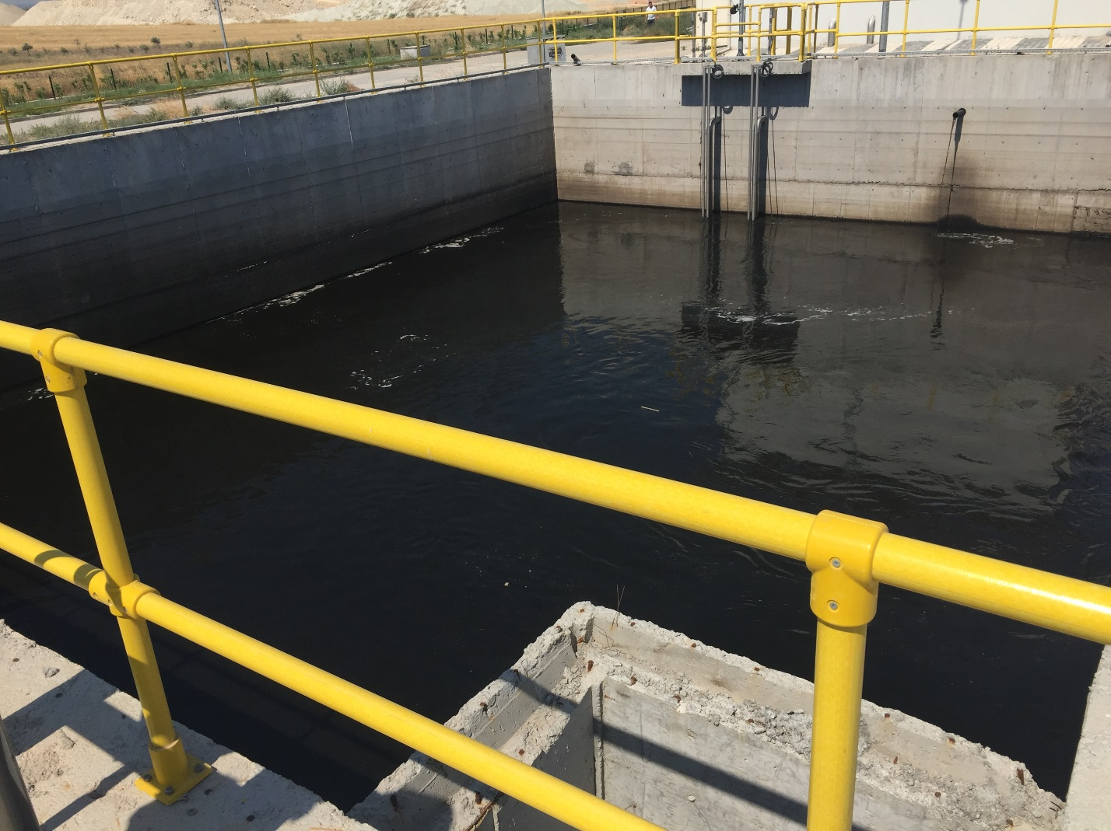

Picture 3

The second section is the pool in the “Picture 3”. There is a secondary pool next this pool. The difference between primary and secondary pool is, secondary pool is a storage. If primary pool is filled, it will send the water to the secondary pool. When primary pool is ready to be filled, secondary pool will be emptied first. Primary pool has a machine inside. The water inside the Primary pool is being stirred by that machine.

The third section is the worst one that smells. Even the door was open the whole time, it doesn’t help. My last days were at that building. The building in “Picture 5” is the picture of the building of third section and “Picture 4” is the picture of the inside. It is a 2 floor building. The machine in the “Picture 4” is located at the second floor. It takes out the small dirt and wastes inside the water, and those small dirt and wastes goes to the trash can at the first floor through a hole. The third section is the last part of the macro part.

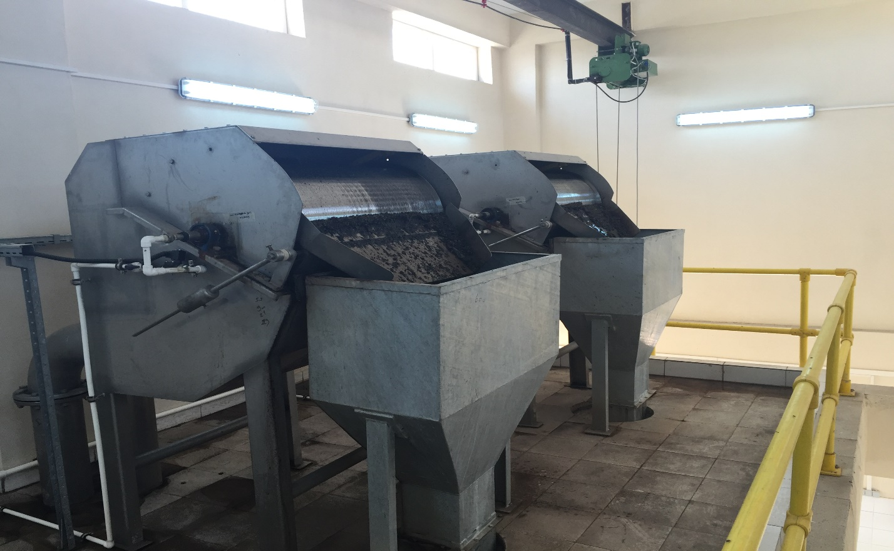Picture 4 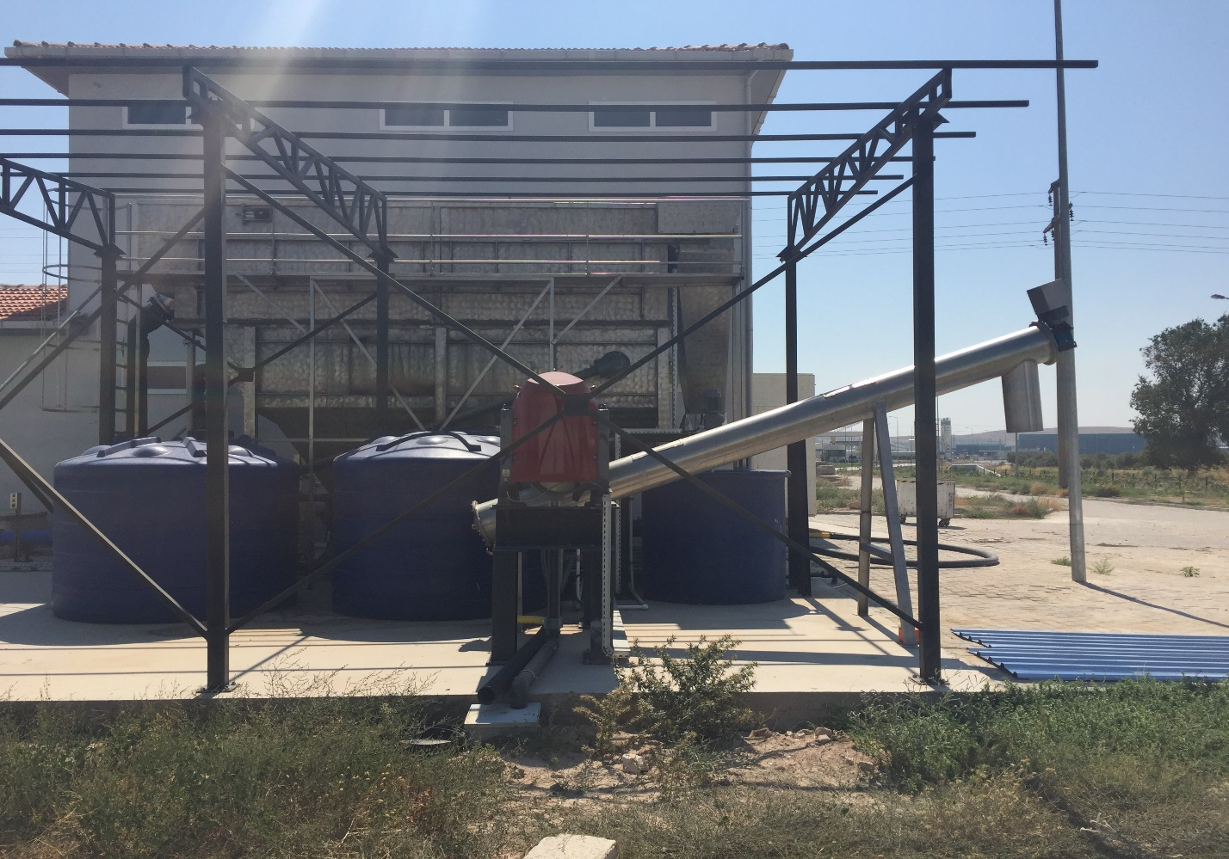Picture 5

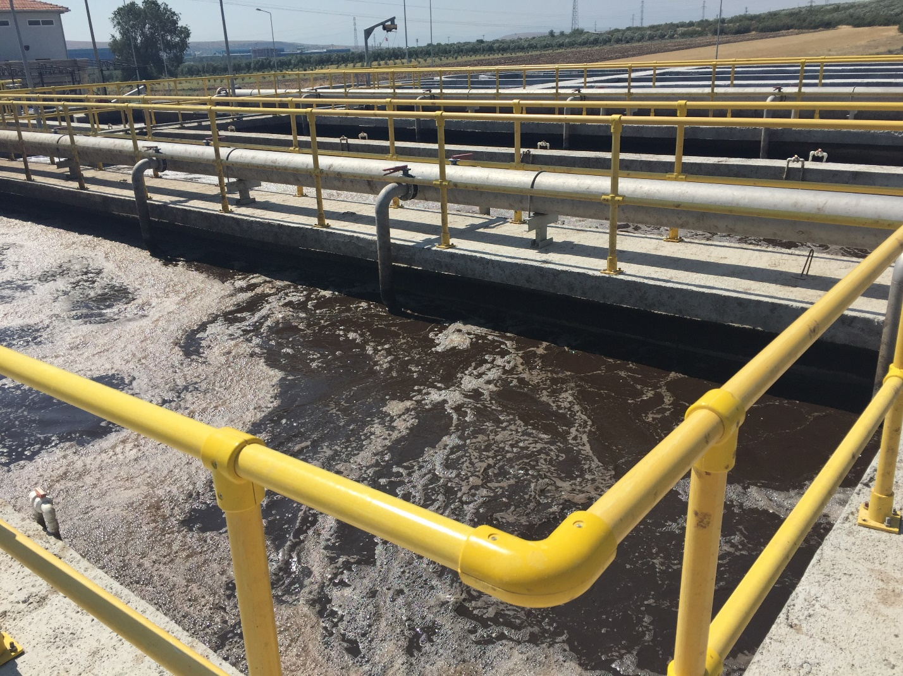Picture 6

“Picture 6” is the fourth section. This where we call bacteria pool. This is the micro part of the water treatment. In this section they produce or in their term “raise” bacteria. To do that they use mud. This bacteria is organic, and its food source is microscopic wastes in the water. The reason why water looks like coffee is because of mud. Sometimes the water inside foams a lot and is about to overflow. To prevent the water from overflowing, they throw chemical to reduce the foam. This is actually the last place where water is being treated.

“Picture 7” and “Picture 8” is part of the MBR. MBR is what we call the fifth section. Just like first section, the “Picture 7” is inside and “Picture 8” is the roof of the concrete building. The roof of the MBR building is visually appealing since it reminds me of the desert named profiterole with a lot of chocolate. At MBR, air is being sent to the water to separate water and mud from each other.

The clean water goes to a canal and from that canal, it is distributed to the factories. There is a huge hole on top of the canal. From that hole, people get a sample and test it. What they are looking for is, what percentage of that water is dirty. Around 5% of uncleanness is acceptable.

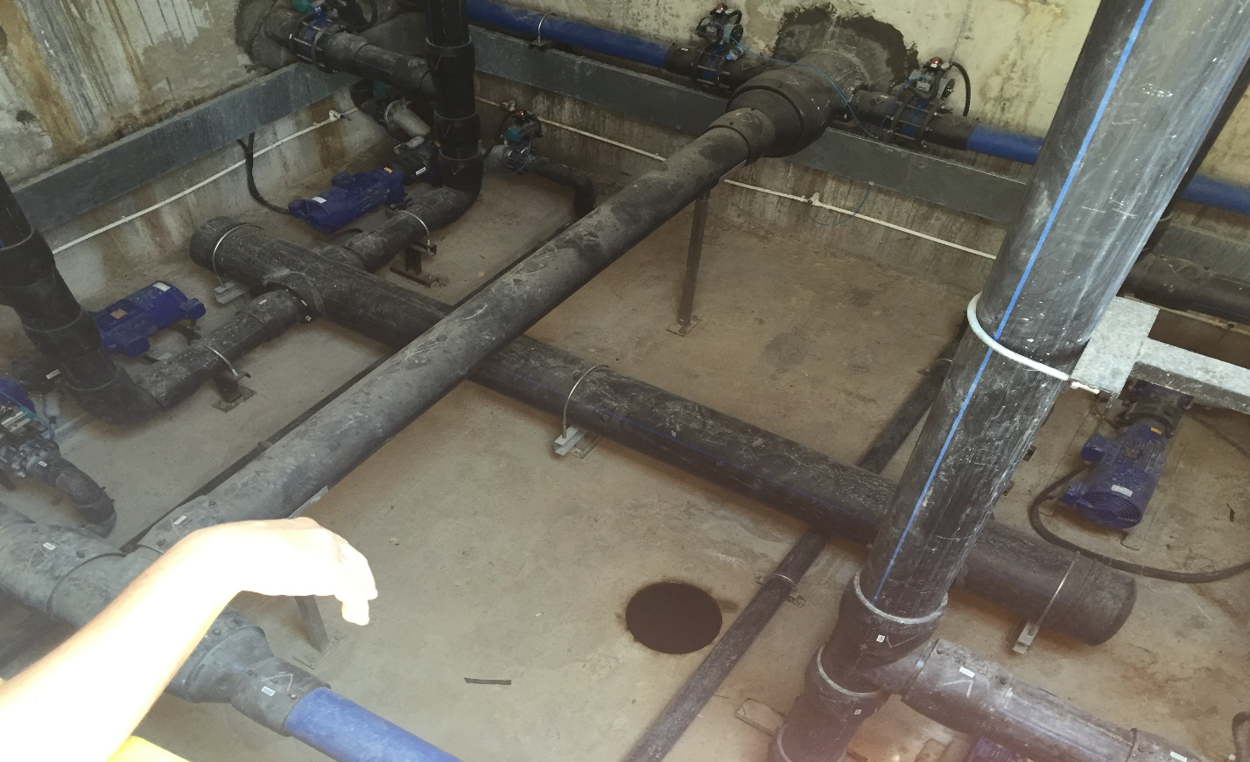

Picture 7: There are 16 valves at these pipes.

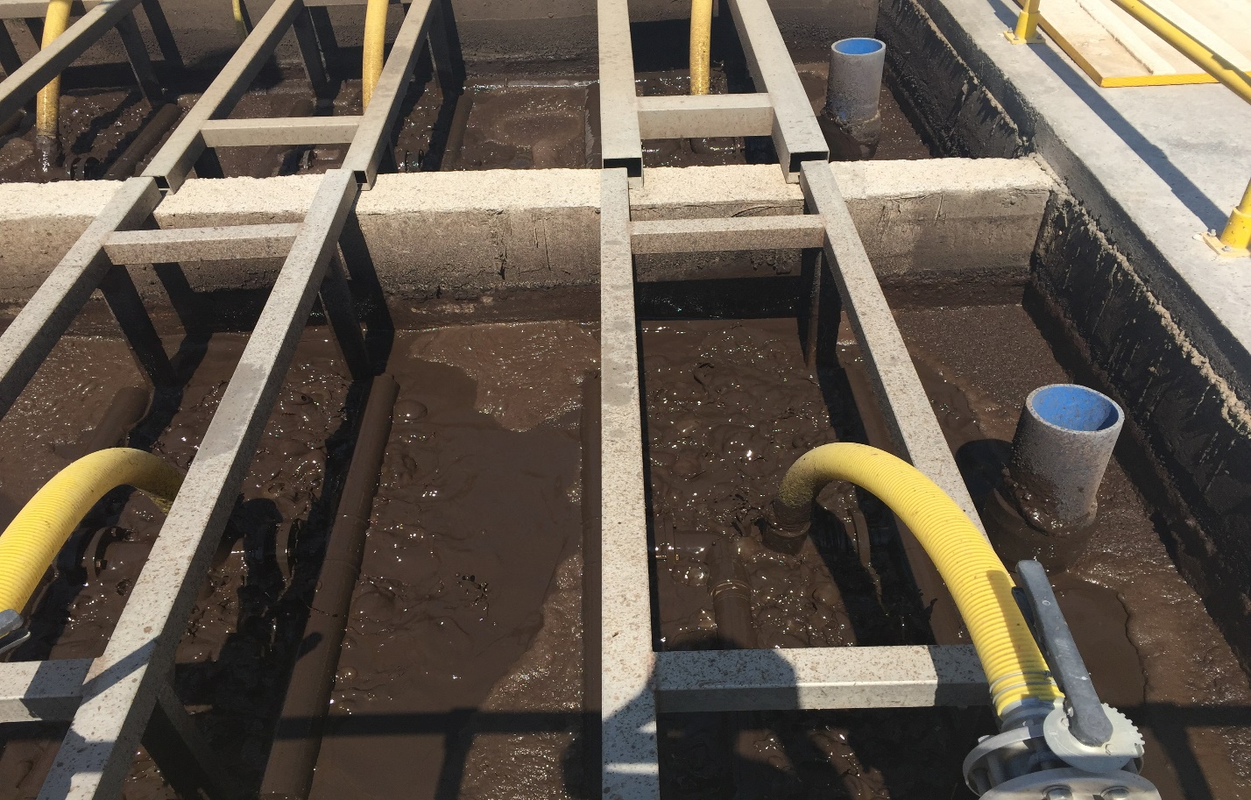

Picture 8

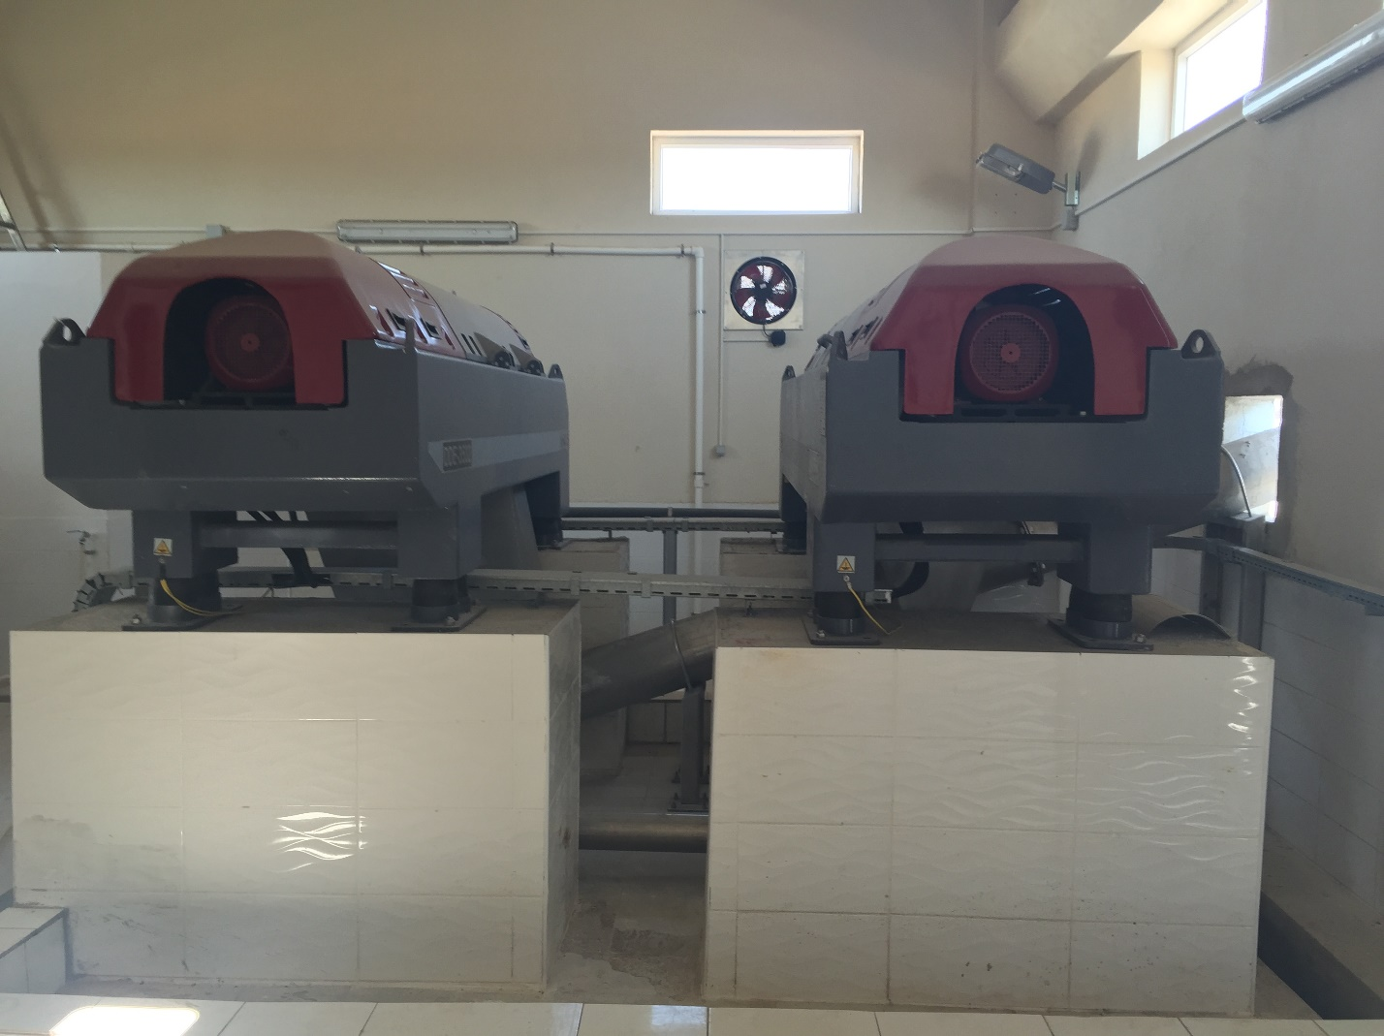

Picture 9: There are two machines that are called “dekantör”. Only one of them when other one is turned off.

“Picture 9” is what we call in Turkish “dekantör”. It is translated as decanter, but I am not sure if I am right about this translation. This section is not considered part of the water treatment process because we are not treating water there. What this “dekantör” does is, it separates the good mud and bad mud from each other. What is good mud, what is bad mud? Good mud is reusable mud. They are sent to the fourth section to produce bacteria. The bacteria needs mud to reproduce. The bad mud is waste. They are sent to the trash container through that window in the “Picture 9”.

Other than those, there is a three floor building. First floor has workshop where workers rest and eat and fix smaller tools, kitchen where we eat breakfast and tea is served from, laboratory where the young lady there makes chemicals like lime remover or tests the samples, and toilet and shower for the workers. Second floor has offices for the people from Goksu Water Treatment firm, and computer room where cameras are being watched and sections are being controlled. All of the sections I mentioned previously have cameras. Third floor belongs to the officials from the government and a meeting room where everybody meet including mayor on Mondays. I had no business there, so I have never gone there.

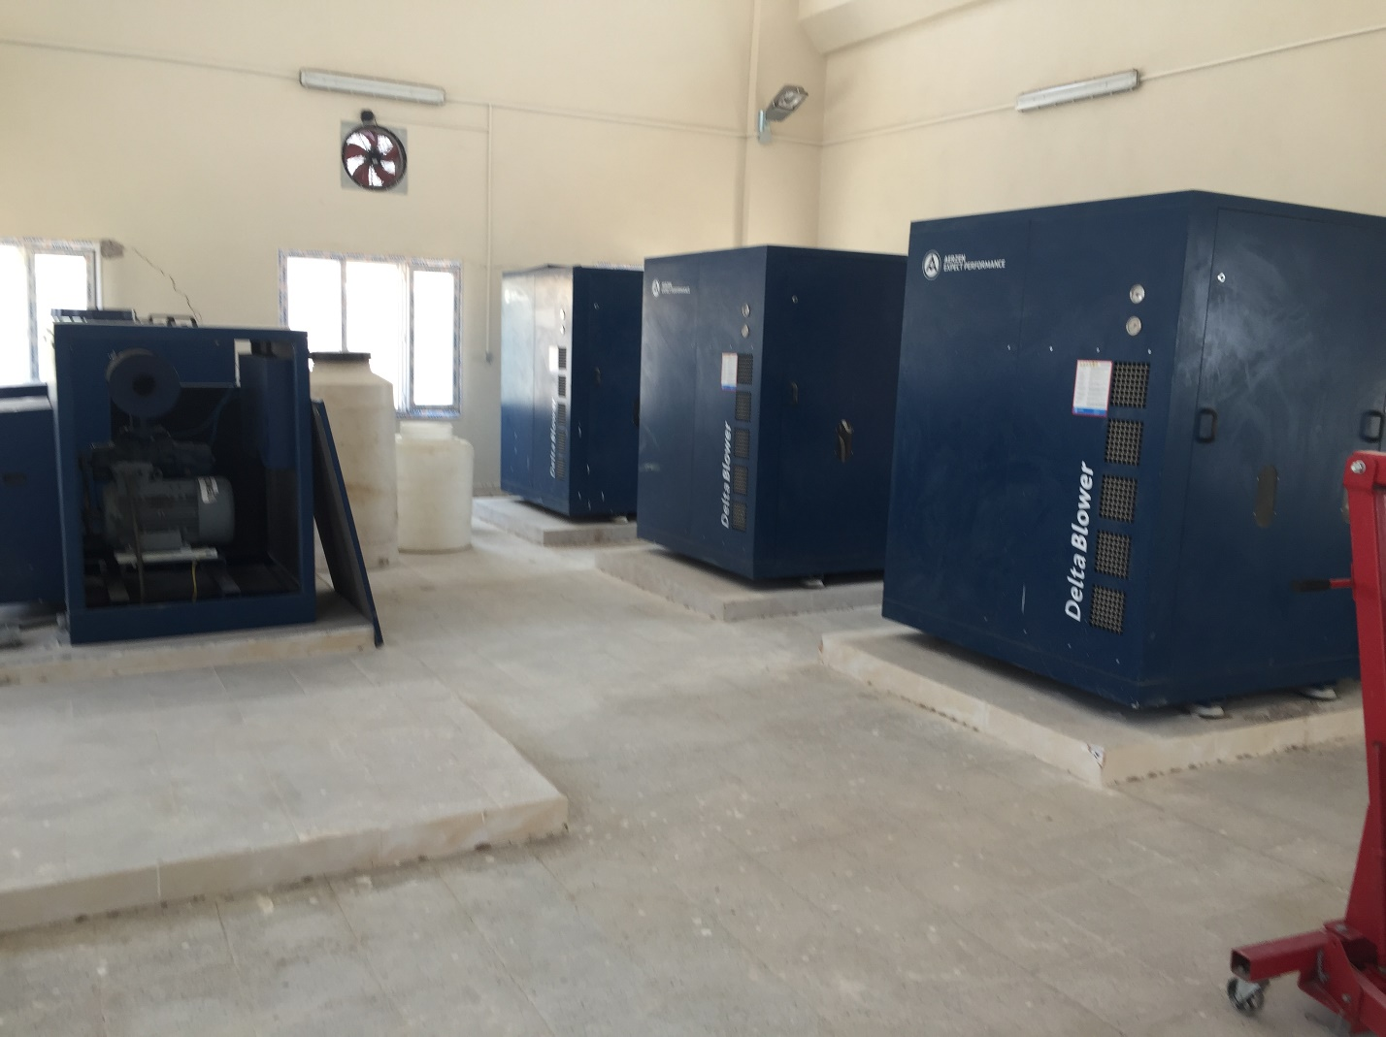

Picture 10

“Picture 10” is the blower section. It doesn’t treat water, but it is not useless. Blower cuts some of the energy consumption of the water treatment plant. This building is the noisiest of them all. You have to wear headphones to enter here. Because this room is huge and cleanest of the all section other than the office, workers put lots of tools and materials here. It can be locked, so it can be considered safe.

First week.

First week I didn’t do anything because most of the people were on vacation. There was nothing for me to do too. I do not even know why they accepted me in the first place, because there was no work for a mechanical engineer left since the whole worksite was built. I was in the room with the supervisor. First day, I had to read the safety rules. Other days, I was just talking with my supervisor, Cemal Kaya, and getting to know them. However, on Thursday, I finally asked to my supervisor to give me a work.

He would usually leave me and meet with Kadir Kusbeci and Cemal Kaya in the room at the “Picture 11”. That was the room where the computer programmer Kadir Kusbeci was working. I said “was” because he was hired from some other firm. He came to the Water Treatment Plant to set up the programs. He was creating a program for the MBR unit. However, the MBR unit in this worksite was different.

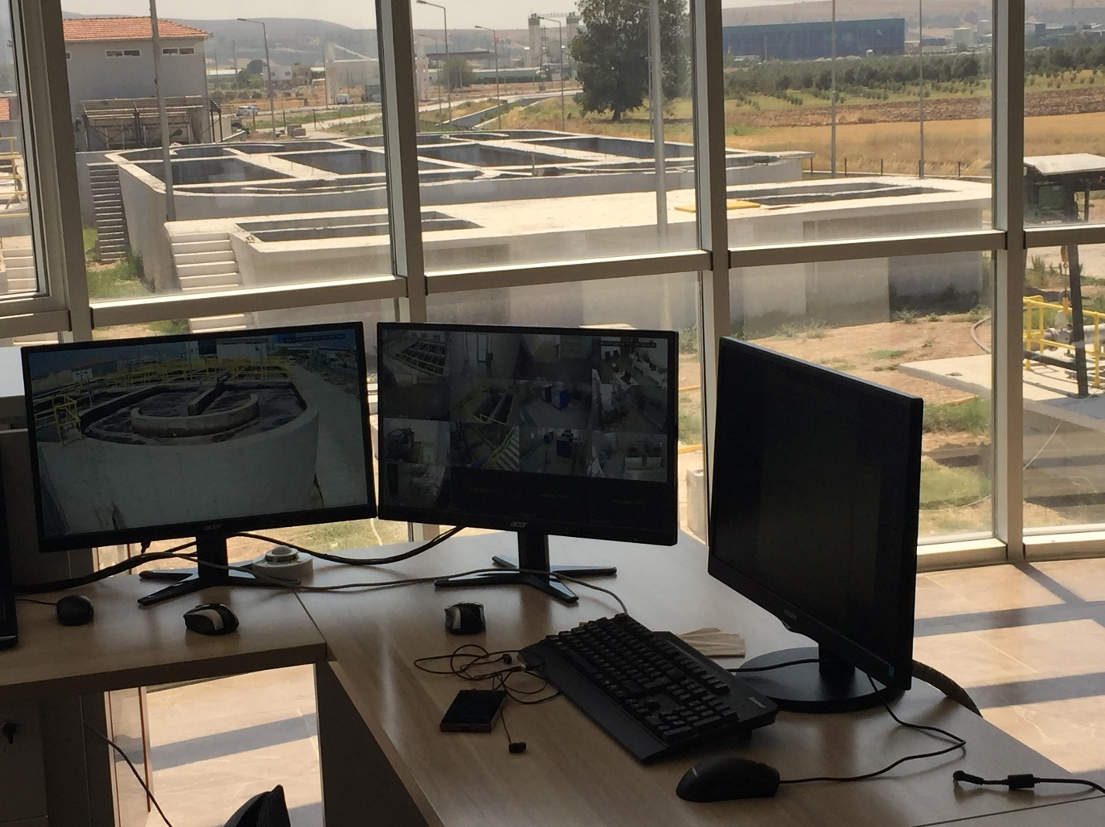

Picture 11: From the camera, all the sections and inside of the office building can be seen. From the window, all of the sections except section one and two can be seen. In the picture secondary section four and five are seen, which are incomplete and section three building can be seen.

The original plan for the MBR section came from another company at the Germany. I do not exactly know the specific of this MBR design because I didn’t work on the design part a lot. This design was different because, this design was first time both companies were doing. For that reason, both parties were having problems and disagreements. It was also hard for them to settle those because they were having most important problem of all, communication.

The company in Germany sent a personnel to discuss with people from the Goksu Water Treatment firm. After personnel from the Germany is convinced that their way of thinking was wrong, he told that to the German company. German company is convinced his way of thinking was wrong. However, the personnel that came to Turkey left the company. New person came to his position and the disagreements and problems started all over again.

After my request for some work to do, my supervisor let me join them for the discussion they were having. The last discussion they were having was about programming the MBR. In “Picture 7”, there are lots of pipes. There are total of 16 pipes. They came to an agreement with the company at the Germany for now, and they were making program for on-off switches for those 16 pipes. They showed me the design, and talked with each other while I was being ignored. I tried to understand as best as I could, but it was no use. I felt like the time when I met with my friends to study for a class, but I do not know the material. They discuss with each other, and I try to listen to them while I also try to understand the material.

I entered the room clueless and left the room confused. I didn’t understand what they were doing, but I knew what they were trying to do. I have taken programming classes before, I also did programming when I was doing my project for the Fluid class. However, as I said, I entered the room without knowing the material. Otherwise, I believe, I would be a lot more useful to the computer programmer.

On Friday, my supervisor told me to help Murat build guard railing on the secondary MBR since I wanted to learn and do some work. I didn’t complain and did the job. I was ready to get myself dirty in this job and I was also bored in the office with nothing to do. Murat was teaching me how to build the railing and use the tools like drill. Using those tools were not as easy as they seemed. You must learn to control those tools first and get used to it. However, it was easier than learning to drive a car. While I was doing that, Kadir Kusteci was building the program for that MBR.

End of the Friday, the program was finished and so was the duty of Kadir Kusteci. We dropped him off to the airport in Izmir, and he flied to the Istanbul from there. I didn’t complain about building guard railing, but when he asked how my first work was felt like, I told him that I didn’t feel like it was a mechanical engineering job. He said mechanical engineers are that, we mechanical engineers are responsible designing guard railing around the machines.

My duties

My duty was originally overseeing maintenance and fixing technical issues with an experienced personnel. That personnel is called Ibrahim Duyan. He is a mechanical engineer at the Goksu Water Treatment Company. He was on vacation after the worksite is finished at Antalya. When he came back from vacation, I don’t if it was act of good, or good will of my supervisor for me or prank of my supervisor on Ibrahim Duyan and workers, every week machines were malfunctioning.

My second week, a lot more workers came caller Oguz, Onur and Eliyas. The first thing that broken was the on-off sign on the valves that are in the MBR. That sign is automatic, when valve is working it shows on, and when valves are off it shows off. I will call that on-off sign since I don’t know the full name of that part. It was not working properly, it was changing signs slowly and sometimes not changing at all when signs when the valves were on or off. Originally we had other problem. The pump on the “Picture 12” were a little separated, so we came there to fix it, but when we were testing it, we noticed the problem with the on-off sign.

There were sixteen valves and sixteen on-off signs. We had to open all of the pumps to ensure they were not loose, and remove and disassemble the on-off sign. When we disassembled on of them, we noticed the small part of the on-off sign, the one in “Picture 13”. It collected too much water that, wasn’t turning off. We had to clean it, and change some of them. There was no reserve of that part left, so we had to buy them from Izmir.

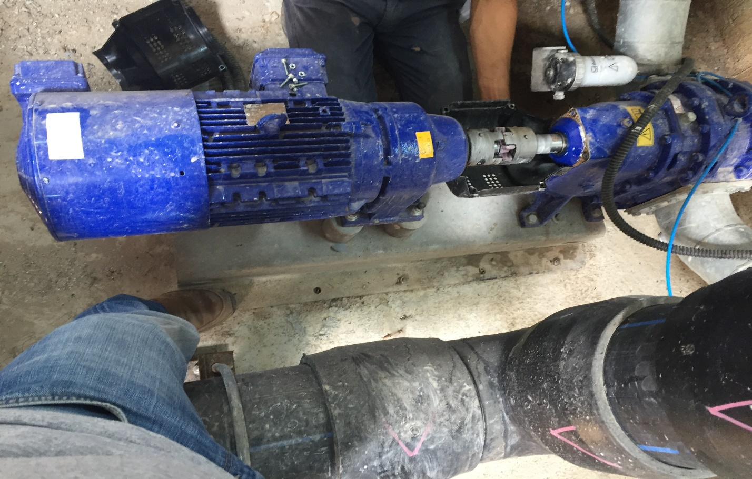

Picture 12: Picture of a pump that is loose.

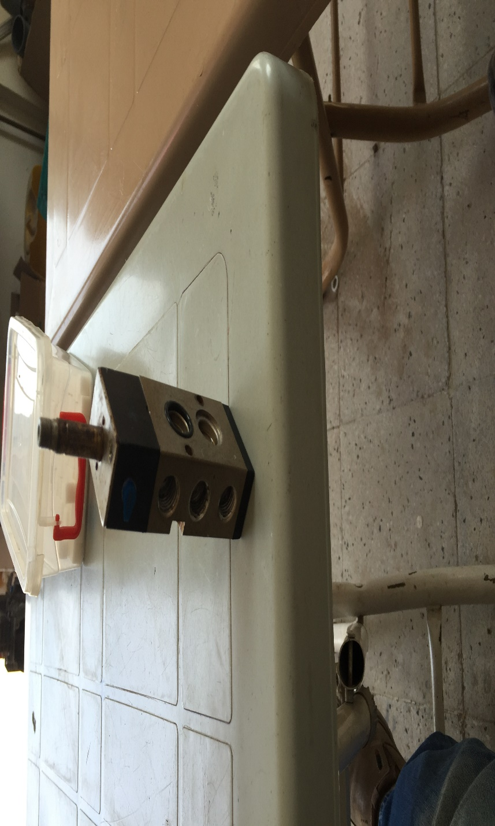

Picture 13

Also inside of the on-off device was filled with lime. And some screws became rusty. We had to get a lime remover from the laboratory. We had to sit and clean the lime from the on-off device. The rust was handled my oiling all of the screws.

The picture 13 is the small part, two of the three holes on the left are for the screw to go in. The middle hole is where air goes in. It makes noise when a valve opens, because air goes out from there. The two holes on the left are where water goes in. When water passes though those holes, it sends a signal to change signs. When water stuck inside, it slowly changes sign of gives on sign only. The top part is like a connection to the whole device.

The third week was worse. The “dekantör” was malfunctioning. The “dekantör” supposed to separate good mud and bad mud and send them to their location. Good mud to the bacteria pool and bad mud to the trash can. However, it wasn’t doing anything. We opened it, it didn’t have any broken part. However, it was full of mud. Both of them. The “dekantör” at right was still better than the one on the left. The pipes were stuck too, so we had to open the empty those machines.

Thank god, whoever made those machines, he/she also didn’t forget the possibility of mud being stuck. There was a button to empty them. And the firm thought of possibility of emptying those machines, so they made a space and a big bump, and a small canal for the dirt to pass through. However emptying the machine was taking too long. Workers had to stay overtime for it. It took around three days to clean those machines. After that, we had to test run those machines without mud to see if they work properly. We only had to dump water on it. The mud would wash off from the canals.

I have heard the reason why the machines got stuck was bad positioning of the pipes where mud passes through. However this is only hearsay from my supervisor. I haven’t come to the worksite because I had a really important document business that I could do on weekday only. I was allowed to not come that day since the road is too long. They fixed the pipes that were positioned badly at the same day.

My last week at the internship, I had to spend most of it in the section three. I had to breathe in the horrible smell of that place. The machine there wasn’t working properly. When I entered that room, those machines weren’t working. Apparently the huge cylinder part of that machine is broken. It wasn’t turning. That cylinder part is supposed to turn and send the smallest dirt to the trash. There was also small burnt device that makes the machine turn.

We had to cut the sides of the machine, so we could take out that huge cylinder part. Then we had to assemble the new cylinder. After we assembled the cylinder, we lifted them up by a forklift. We placed on their location, and put the sides back. We had to use silicone to glue the sides.

The reason why it was postponed until my last day was because that cylinder arrived newly. Ibrahim Duyan told me that the cylinder is specially made. The only location that produces those cylinders is in France. The other burnt part could be found in Turkey.

Aftermath

After I was done with this internship, I understood why I didn’t get a place in the Dreamline Olympics I participated in Turkey. I and a friend designed it, and our project was about saving money and clean water by using dirty waters from the washing machine and sink for the flush. I thought at first, they didn’t like our project because we couldn’t explain it properly or the idea sounded disgusting to them. However, now I understand that with few filters, you can’t have a clean toilet flush. It requires more money and maintenance. However, the Dreamline is about cheap and low maintenance projects.

Sadly, from my experience at the workshop, I couldn’t connect too much courses I took before. The position I had didn’t require any calculation. However, I am also not planning to get a career like that, where I have to oversee maintenance and fix technical stuffs. I just wanted to work there because it looked easy for my first mechanical engineering experience.

Even though I haven’t used a lot of engineering knowledge connected to the classes, I still understood how much the classes I took would help me as an engineer. One of them is computer programming classes. When Kadir Kusbeci was building the program for the MBR, everybody were having hard time. Other than the fact that project was the first time they used the new model, my supervisor and Cemal Kaya were from older generation. They didn’t understand computer language. That is why they were having hard time communicating.

The Fluids class I just took during Summer 1 made me understand some concept at the water treatment plant. Bacteria pool and MBR are at the same high. That way, it requires no power to send the water between two high altitudes. The fluids will always equals at same altitude under the atmospheric pressure. I also believe, if I was the one who designed the plant facility, knowledge of fluid flow would be necessary.

From the machines and buildings, static and dynamic classes would be necessary as well. Those two classes are the foundation of the most engineering majors. Static is about standing objects. Buildings are really good example for static. They have to keep staying same way, and be able to carry a lot of people or water in this case. Dynamics, is about moving objects. Most of the machines are included in this category since they are moving. Like the huge rod inside the water pool at section 2 that stirs the water. That rod is mechanical that stands vertical, but it keep rotating around the center of the pool. The other example for the mechanical device would be the one in the section three. The cylinder inside always rotates around itself, so the dirt goes to the trash can.

I have not taken any other engineering classes other than Thermodynamic. Thermodynamic is about transfer of energy. I didn’t see any transfer of energy situation in that place. Of course that would also mean, that I have to measure the temperature, pressure, mass flow, etc… of the water at all sections. I didn’t have any luxury of measuring anything.

For the engineering classes that I have not taken yet, I believe design would be the most important. Because design the devices, designing the buildings, pools would be very important. Since I didn’t take other engineering classes, I can’t say anything about them, because I don’t know what they are about.

I am not talking about foundational classes like Physics and Mathematics. I have never used those skills. However, I accidentally saw my supervisor was doing physics and mathematics for the project they are building at Kapkan. However, I know that calculating size of device, weight of a material, radius of a pipe are important at water treatment facility.